CHAPTER 4: SYSTEM DESIGN AND IMPLEMENTATION
4.1 Introduction
This chapter presents the design and implementation of the proposed Federated Intrusion Detection System (FL-IDS) artefact. The chapter describes the architectural design, system components, dataset handling procedures, machine learning integration, visual analytics generation, and implementation workflow adopted during the development of the artefact.
The developed system integrates a Java-based graphical user interface with a Python-based machine learning engine to support intrusion detection evaluation, federated learning simulation, and result visualization. The implementation focuses on providing a reproducible and interpretable framework for evaluating intrusion detection performance using machine learning techniques and visual analytics.
The chapter further explains how federated learning concepts, drift-awareness principles, and adversarial defense concepts were incorporated into the overall system design framework
4.2 Design Goals
The design of the proposed artefact was guided by the following goals:
- To support distributed intrusion detection simulation using federated learning concepts
- To preserve modular separation between interface, processing, and evaluation components
- To enable multi-class intrusion classification
- To provide interpretable visual analytics
- To support extensibility for future drift-aware and adversarially robust enhancements
- To provide a reproducible academic artefact suitable for third-party evaluation
The artefact was therefore designed as a modular multi-layer framework integrating data processing, machine learning evaluation, and visualization functionality.

4.3 High-Level System Architecture
The proposed system adopts a layered architecture consisting of:
- Presentation Layer
- Dataset Processing Layer
- Machine Learning Layer
- Visualization and Results Layer
The architecture integrates Java Swing graphical components with Python machine learning scripts and generated evaluation outputs.
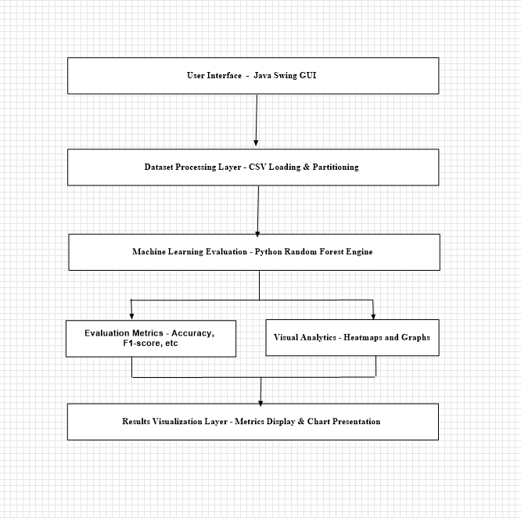
Proposed FL-IDS System Architecture
Figure 4.1: Proposed FL-IDS System Architecture
Figure 4.1 illustrates the overall architecture of the proposed FL-IDS artefact. The Java-based graphical interface interacts with the dataset processing and machine learning layers to support intrusion detection evaluation and visual analytics generation. The machine learning engine generates metrics and charts which are subsequently loaded into the graphical interface for interpretation.
4.4 Presentation Layer
The presentation layer was implemented using Java Swing within the NetBeans development environment.
The graphical user interface provides interaction capabilities including:
- Dataset loading
- Dataset preview
- Partition generation
- IDS evaluation execution
- Results visualization
- Chart loading
The interface was designed to simplify experimentation and improve usability for third-party evaluators.
The main interface contains multiple tabs including:
- Data Tab
- Nodes Tab
- Training Log Tab
- Results Tab
The Results Tab dynamically loads generated charts and evaluation summaries.

4.5 Dataset Processing Layer
The dataset processing layer handles dataset loading, preprocessing, and partition generation.
CSV datasets are loaded through file selection dialogs and parsed into structured tabular representations for subsequent processing.
The dataset processing workflow includes:
- Dataset loading
- Feature extraction
- Label separation
- Dataset partitioning
- Training/testing split preparation
The system was primarily evaluated using the NSL-KDD dataset.
Dataset Processing Workflow
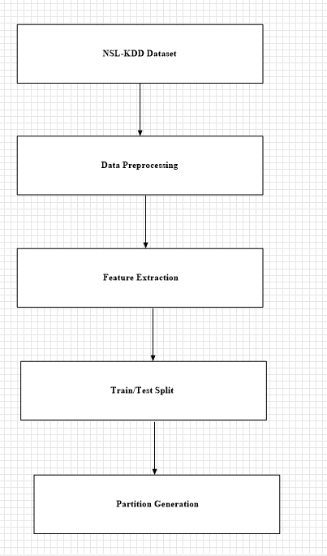

Figure 4.2: Dataset Processing Workflow

Figure 4.2 illustrates the dataset processing workflow implemented within the artefact. The NSL-KDD dataset undergoes preprocessing, feature extraction, training/testing partitioning, and federated simulation partition generation.
4.6 Federated Learning Simulation
The artefact incorporates federated learning concepts through simulated distributed client partitioning.
Rather than deploying a fully distributed federated infrastructure, the implementation simulates federated environments using dataset partitions representing independent client nodes.
Each simulated node processes a subset of the dataset independently, enabling experimentation under heterogeneous data distribution conditions.
The federated simulation framework was included to support future extension toward fully distributed federated learning implementations.
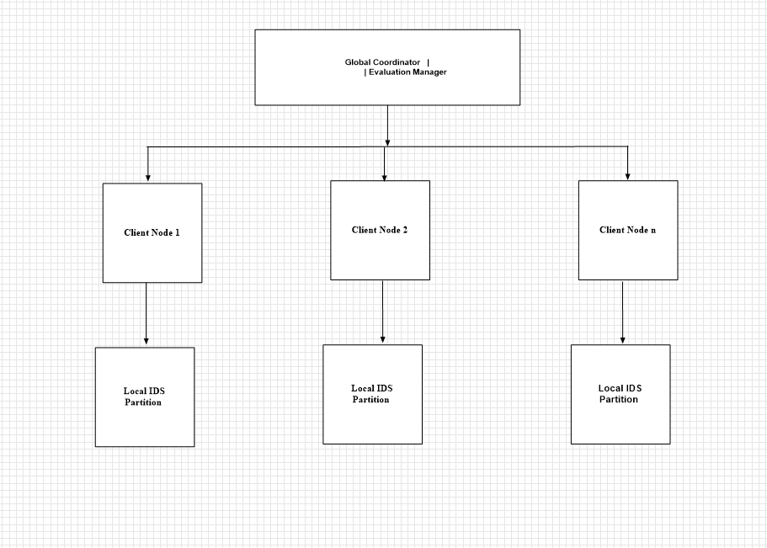
Figure 4.3: Federated Learning Simulation Model
Figure 4.3 illustrates the federated simulation environment used during evaluation. Multiple dataset partitions simulate distributed client nodes operating independently under federated learning conditions.
4.7 Machine Learning Evaluation Layer
The machine learning evaluation layer was implemented using Python.
The evaluation engine performs:
- Dataset loading
- Random Forest training
- Prediction generation
- Metric computation
- Chart generation
The Random Forest classifier was selected due to its:
- high classification accuracy,
- robustness,
- resistance to overfitting,
- strong multi-class performance.
The implementation utilized the Scikit-learn machine learning library.

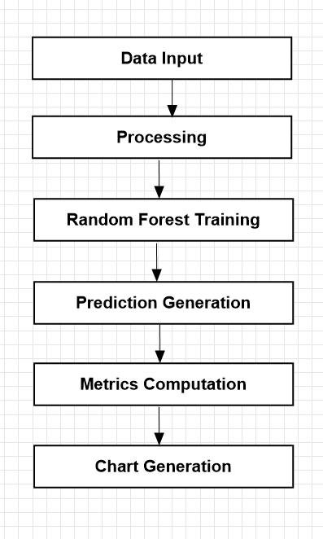

Figure 4.4:Machine Learning Evaluation Pipeline
Figure 4.4 illustrates the machine learning workflow used during evaluation. The Random Forest classifier processes the dataset and generates performance metrics together with visual analytics outputs.
4.8 Evaluation Metrics Generation
The artefact generates several evaluation metrics including:
- Accuracy
- Precision
- Recall
- F1-score
- Confusion Matrix
The metrics are exported into structured files including:
- metrics.json
- confusion_matrix.csv
- predictions.csv
- attack_summary.csv
These outputs are subsequently loaded into the graphical interface.
4.9 Visual Analytics Integration
Visual analytics were integrated into the artefact to improve interpretability of intrusion detection results.
The system generates multiple graphical outputs including:
- Confusion matrix heatmaps
- Overall metrics bar charts
- Attack distribution charts
- Per-class F1-score charts
- Actual versus predicted distribution graphs
The charts are generated using the Matplotlib library and stored within the charts directory.

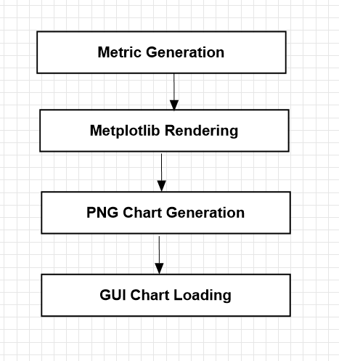
VISUAL ANALYTICS WORKFLOW

Figure 4.5: Visual Analytics Workflow
Figure 4.5 illustrates the visual analytics workflow implemented within the artefact. Evaluation metrics generated by the machine learning engine are transformed into graphical visualizations for interpretation within the Java interface.
4.10 Drift Awareness Concepts
The system architecture incorporates conceptual support for drift-awareness mechanisms informed by techniques such as:
- KS-Test
- Page-Hinkley
- ADWIN
These techniques were studied and integrated into the conceptual architecture to support future adaptive intrusion detection enhancement.
Although full online drift adaptation was not implemented within the current artefact, the framework was designed to support future integration of adaptive retraining and statistical drift monitoring mechanisms.
4.11 Adversarial Defense Concepts
The proposed architecture also incorporates conceptual adversarial defense considerations including:
- trust-aware aggregation,
- anomaly filtering,
- Mahalanobis distance-based outlier analysis,
- robust aggregation strategies.
These mechanisms were investigated as part of the architectural design framework to support future research into adversarially robust federated intrusion detection systems.
The current artefact primarily focuses on machine learning evaluation and visual analytics rather than full adversarial defense implementation.
4.12 System Implementation Technologies
The following technologies were used during implementation:
4.12 System Implementation Technologies
The following technologies were used during implementation:
Technology | Purpose
Java | GUI development
Java Swing | Interface design
Maven | Management of dependences
Python | Machine learning engine
Pandas | Data processing
Scikit-learn | Model training
Matplotlib | Chart generation
Git/GitHub | Version control
4.13 Artefact Packaging
The artefact package was structured to support third-party reproducibility and evaluation.
The package includes:
- Source code
- Documentation
- Installation instructions
- README files
- Batch execution scripts
- Sample datasets
- Generated charts
Execution support files include:
launch_gui.bat
run_ids_pipeline.bat
These scripts simplify artefact deployment and evaluation.
4.14 Challenges Encountered During Implementation
Several challenges were encountered during implementation including:
- Java-Python integration complexity
- Large dataset management
- GitHub repository size limitations
- GUI synchronization issues
- Resource consumption during chart generation
These challenges were addressed through modular implementation, repository optimization, and staged execution workflows.

4.15 Chapter Summary
This chapter presented the design and implementation of the proposed FL-IDS artefact. The chapter described the system architecture, dataset processing workflow, federated learning simulation, machine learning evaluation engine, visual analytics integration, and implementation technologies.
The chapter further demonstrated how drift-awareness and adversarial defense concepts were incorporated into the conceptual design framework while maintaining alignment with the implemented artefact.
The next chapter presents the experimental evaluation and analysis of the results generated by the system.

